Design of pectin based hydrogels with tunable structures

M. Börjesson^{1,2}, A. Maire du Poset^{2,3}, P. Fouilloux³, C. Loupiac³, A. Assifaoui³, A. Ström¹ and F. Cousin²

¹ Chemistry and Chemical Engineering, Chalmers Univ. of Technology, Gothenburg, Sweden.
² Laboratoire Léon Brillouin, UMR 12, CEA-CNRS, Gif Sur Yvette, France.
³ Equipe PAPC, UMR PAM, AgroSup Dijon Université de Bourgogne, Dijon, France.

Mixtures of anionic polysaccharides and globular proteins are of great interest with respect to the design of innovative biomaterials and to their large variety of applications in the food, pharmaceutical, biotechnology and cosmetic industries. In this framework, the structure of aqueous mixtures of polygalacturonic acid (PGA) and a protein, β-lactoglobulin (BLG), is studied in presence of calcium divalent cation (Ca²⁺) at a neutral pH. At neutral pH, both BLG and PGA will be negatively charged giving a repulsive effect to avoid aggregation.
An external gelation process for producing repetitive, PGA-hydrogels with a natural concentration gradient has been developed at the research lab^{1,2}. The gelation process is induced by divalent cations at room temperature and the PGA network can entrap proteins inside its gel structure. The hydrogels studied here is obtained from PGA, a model substance for the family of pectin polysaccharides. The structure in relation to methyl ester substitution is studied using small angle neutron scattering (SANS). Following this, BLG, a globular, close-packed and well-ordered protein that is one of the major components of whey protein from bovine milk, is mixed with the PGA to give a hydrogel with a polysaccharide network decorated with BLG particles, as illustrated in Figure 1. BLG is known for its specific transporter activity carrying small hydrophobic ligands such as vitamin A and D, fatty acids and, cholesterol and enables as a carrier of these molecules inside the hydrogels.
By entrapping BLG molecules (or other potential drugs/substances) inside the PGA network, the BLG release can be studied and depending on the natural concentration gradient inside the gel, different release profiles can be achieved. By playing with several parameters such as the ratio (PGA/protein), the structure of the protein (native, unfolded), the amount of divalent ion and, the degree of methyl esterification, the structure and function of the hydrogels can be tuned.
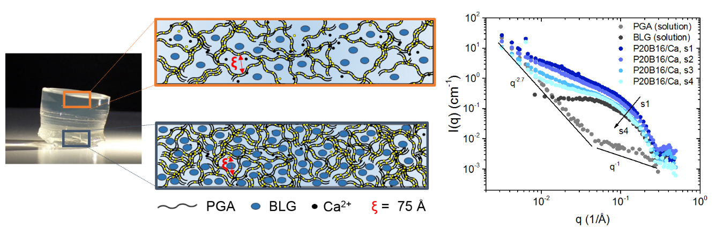
Fig. 1: An illustration of the PGA network structure induced by Ca²⁺ where the BLG protein decorates the polysaccharide network². The graph shows the SANS results in different slices of the gel where s1 is the lower, high concentrated part and s4 the upper, less concentrated part of the gel.

References:
1 Maire du Poset, A., Lerbret, A., Zitolo, A., Cousin F. and Assifaoui, A. (2018). Design of polygalacturonate hydrogels using iron(II) as cross-linkers: A promising route to protect bioavailable iron against oxidation. Carbohydrate Polymers, 188, 276-283.
2 Maire du Poset, A. (2018). Hydrogels de polygalacturonate réticulés par les ions Fe²⁺: Impact du mode d’association local sur les mécanismes de gélification, contrôle de la structure à différentes échelles et modulation des propriétés mécaniques (Doctoral dissertation). Université Bourgogne Franche-Comté, Dijon, France

