Chitosans and cyclodextrin polymers to design new biodegradable antifungal coating

A Loron¹, C Gardrat¹, V Atanasova-Penichon ², N. Tabary ³, B. Martel ³ and V Coma¹

¹Laboratoire de Chimie des Polymères Organiques UMR 5629, 16 Avenue Pey-Berland 33607 Pessac, France
²Department Centre INRA de Nouvelle Aquitaine—Bordeaux UR1264 MycSA, INRA, 71 avenue Edouard Bourlaux 33883 Villenave d'Ornon, France
³ Unité Matériaux Et Transformations UMR CNRS 8207, Université de Lille Batiment C6, 59655 Villeneuve D’ascq, France

The pathogenic fungal strain Fusarium graminearum is responsible for the disease Gibberella Ear Rot in maize and Fusarium Head Blight in wheat. The diseases caused by Fusarium not only severely decrease grain yield, but also result in contaminated grains with an unacceptable levels of mycotoxins, which are toxic secondary metabolites. Hence, such fungal strains can drive the outbreaks of mycotoxicosis in humans and animals mainly via the consumption of cereals. F. graminearum can produce some class B CMR mycotoxins, such as trichothecenes.
To control the fungal development, traditional antifungal substances may be used but they are not sufficiently efficient on mycotoxin production while being harmful to human health and environment. In consequence, new safer active formulations, especially based on natural antifungal agents, are today critically required.
As potential food preservatives, active biopolymers such as chitosans and natural extracts such as phenolic compounds have received lots of attention to be use in new antimicrobial formulations.^{1,2,3} The first aim of the present study is to determine the relationships between the chitosan structure and the antifungal and antimycotoxinogen properties. Knowing that the selected curcumin derivative – tetrahydrocurcumin THC- is unfortunately a scarcely water-insoluble molecule, different cyclodextrins were studied to enhance the apparent aqueous solubility. Polymers of β-cyclodextrins synthesized from citric acid as the cross-linker agent showed promising results (Fig.1).

Fig. 1.
(A) Fusarium graminearum I349 on PDA medium supplemented with anionic polymer of MeβCD at 50 g/L and THC at env. 0.25 mM after 5 days after inoculation, in the dark, at 25°C, relative humidity = 70%.
(B) Fusarium graminearum I349 on PDA medium after 5 days after inoculation, in the dark, at 25°C, relative humidity = 70%.
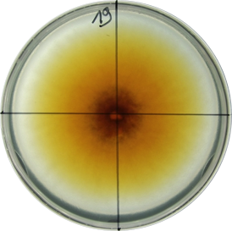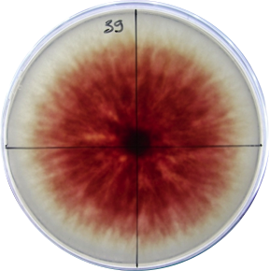
A B

References:
- Portes, E., Gardrat, C., Castellan, A. and Coma, V. (2009). Chitosan films incorporating tretrahydrocurcuminoid antioxidant molecules. Desorption in methanol and bioactiviy against Listeria innocua. Carbohydrate Polymers, 76, 578-584.
- Zimoch-Korzycka, A., Gardrat, C., Al Kharboutly, M., Castellan, A., Pianet, I., Jarmoluk, A., and Coma, V. (2016). Chemical characterization, antioxidant and anti-listerial activity of non-animal chitosan-glucan complexes. Food Hydrocolloids, 61, 338-343.
- Etxabide, A., Coma, V., Guerrero, P., Gardrat, C., and De la Caba, K. (2017). Effect of cross-linking in surface properties and antioxidant activity of gelatin films incorporated with a curcumin derivative. Food Hydrocolloids, 66, 168-175.

