Optimization of clean-label oleogel-structured emulsions: an experimental design approach

D. Huc-Mathis¹, A. Sander¹, and D. Blumenthal¹

¹Université Paris-Saclay, INRAE, AgroParisTech, UMR SayFood, 91120 Palaiseau, France

Liquid oil structuring is becoming a major stake for food and bioproducts formulation. This is firstly attributed to health considerations since for example, excessive consumption of trans and saturated fats can degrade human cardiovascular health. As a consequence, the “REPLACE” campaign launched by the World Health Organization (WHO) in 2018 is specifically targeting the trans fats replacement with healthier fats and oils (World Health Organization, 2019). Secondly, some sources of semi-solid vegetal oils such as palm are being questioned about their sustainability. Thus, it is clear that some efforts must be made in order to identify more sustainable still safe and healthy fats, in order to target various applications such as foods and cosmetics.

Among the investigated strategies, oleogels are booming, in order to avoid chemical modifications of the vegetal oils such as hydrogenation. Organogels are three-dimensional structures with the ability to retain large amounts of non-polar liquids in their gel network. In the case of edible oil for foods and bioproducts, the obtained semi-solid systems are called oleogels. They are structured thanks to oleogelators, encompassing small surfactants such as phospholipids, sugar esthers or mono-diglycerides, waxes, fatty acids and polymers such as cellulose or proteins. However, three recurrent features can be noticed in literature: 1) the fabrication process is often carried out in two steps, requiring a first emulsification and gelation before the water is removed to finally create the oleogel after shearing; 2) the oleogelators are all pure ingredients, except the waxes which can encompass various molecules in one ingredient; 3) natural oelogelators such as cellulose are often chemically modified or heated at high temperatures (>120°C) in order to be efficient. As a consequence, if oleogelation can be an alternative to trans fats, its environmental impact should not be forgotten and requirement of various processes or chemical modifications should be avoided.

The present work is investigating the gelation of vegetal oils by a mix of only 2 natural ingredients, not purified nor chemically modified (beeswax and up-cycled oat bran). Water was also added and never removed in order to obtain “oleogel-structured emulsions” (OGE). An experimental design was carried out in order to understand the structure-function relationships in these clean-label oloegels, regarding common emulsion features such as viscosity and physical stability. We are aiming for facilitating the knowledge transfer towards formulation of innovative products based on 100% natural ingredients (including up-cycled agri-wastes) and avoiding the use of solvents or extraction/purification process steps.

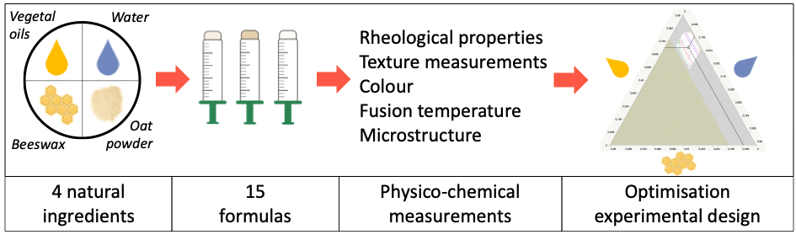
Figure 1: Graphical synthesis of oleogelation based on natural ingredients and a one-step process

