Functional particles for novel micro-structured food manufactured by membrane emulsification

M Dragosavac

Department of Chemical Engineering, Loughborough University, Ashby Road, LE11 3TU, Loughborough, United Kingdom

Production of larger droplets of controlled diameter is becoming increasingly popular. Those droplets after additional treatment can be turned into particles and applied in industries as food and flavour encapsulates, controlled release depots under the skin, medical diagnostic particles, high value fillers, electronic ink capsules, ion exchange resins (Fig. 1). Conventional devices for preparing emulsions apply more energy than needed to produce droplets, leading to droplets with a wide size distribution and such devices are not suitable if temperature/sheer sensitive compounds should be encapsulated.
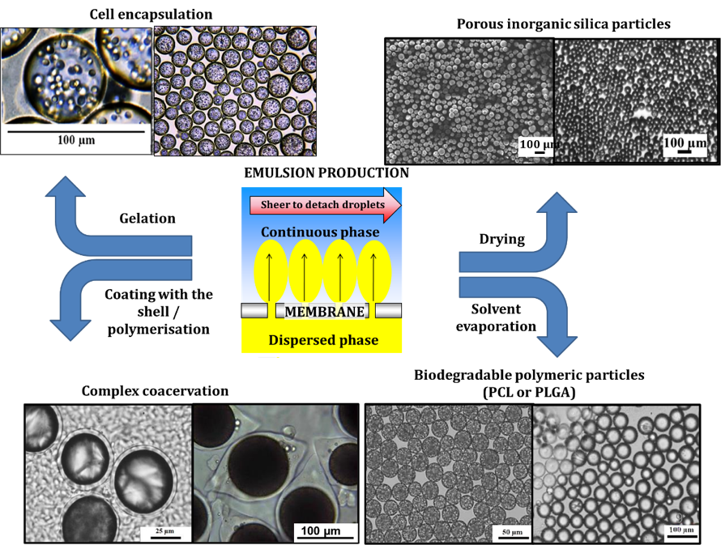
Fig. 1 Particles manufactured by membrane emulsificaiton
Membrane emulsification (ME) is a dispersion process to produce monosized droplets of one liquid phase (e.g. oil) in a second immiscible liquid phase (e.g. water) using low energy per unit volume where the shear stress applied on the membrane surface influences the droplet size. A new ME technique (dispersion cel^{1,2}, torsional³, and “cross-flow” ME⁴) developed at Micropore Technologies Ltd. UK in collaboration with Loughborough University were introduced for generating the shear on the membrane surface providing the possibility to generate larger droplets without risk of breakage with possibility for scaling up. Using these techniques, it is possible to generate highly uniform drops/particles between 10 and 1000 µm with the production volume capacity of up to 1500kg/hr using the “cross-flow” system.

References
1 Morelli, S., Holdich, R.G. and Dragosavac, M.M., 2017. Microparticles for cell encapsulation and colonic delivery produced by membrane emulsification. Journal of membrane science, 524, pp.377-388.
2 Pu, X., Wolf, B. and Dragosavac, M., 2019. Generation of magnesium enriched water-in-oil-in-water food emulsions by stirred cell membrane emulsification. Journal of Food Engineering, 247, pp.178-187.
3 Imbrogno, A., Dragosavac, M.M., Piacentini, E., Vladisavljević, G.T., Holdich, R.G. and Giorno, L., 2015. Polycaprolactone multicore-matrix particle for the simultaneous encapsulation of hydrophilic and hydrophobic compounds produced by membrane emulsification and solvent diffusion processes. Colloids and Surfaces B: Biointerfaces, 135, pp.116-125.
4 Holdich, R., Dragosavac, M., Williams, B. and Trotter, S., 2020. High throughput membrane emulsification using a single‐pass annular flow crossflow membrane. AIChE Journal, 66(6), p.e16958.

