Stabilizing clean-label emulsions with uncracked by-products: a story of heterogeneity

D. Huc-Mathis¹, C. Hollestelle¹, M. Masson¹, D. Blumenthal¹, C. Michon¹

¹Université Paris-Saclay, INRAE, AgroParisTech, UMR SayFood, 91120 Palaiseau, France

Food is, as many composite materials, currently based on a core paradigm: it’s made from an assembly of standardized pure fractions. Extracted and purified from a raw material, they are usually dedicated to one desired property, such as emulsifying, foaming, viscosifying, gelling, coloring, preserving etc. While cracking means control, thanks to the fractionation process leading to standardization of the ingredients, it also requires additional solvents, dedicated process steps to purify the recovered fractions, creates a great deal of wastes and can even lead to some loss of functionality. Thus, refining ingredients has recently been questioned regarding both nutritional and environmental impacts.

We are challenging the cracking paradigm, investigating a new way to consider food ingredients through a zero-fractionation route and a specific vegetal deposit, i.e. food by-products. The stabilizing potential of these unconventional biomasses is assessed as whole flours mixed with oil and water in emulsions. Hybrid interfaces are created, stabilized by a native mix of surfactants, proteins and/or other polymers, as well as insoluble particles. In that regard, heterogeneity is not a weakness that should be avoided through standardization, but a strength to be engineered in order to keep the complementary functional properties of the different components together. The remaining challenge is to understand and prioritize the structuring mechanisms of such uncracked materials.

We explored a wide range of fat content (5 to 80% wt/wt) as well as various sources of by-products (apple and orange pomace, oat bran…). Starting from model system oil + water + by-product powder, we were able to build up the complexity towards realistic products (food and cosmetic applications). Several proofs of concept were obtained and some first hypotheses about the structuring mechanisms from the soluble and insoluble components were validated. The soluble compounds are mainly responsible for the oil droplets size while the insoluble compounds are shielding the droplets against coalescence, demonstrating their complementarity. Such strategy will unlock a new way of considering plant-based materials, by questioning the appropriate level of purity of vegetal ingredients. This alternative to the current cracking paradigm can make a real difference in thinking the new bioeconomical sector that will be built around by-products management.

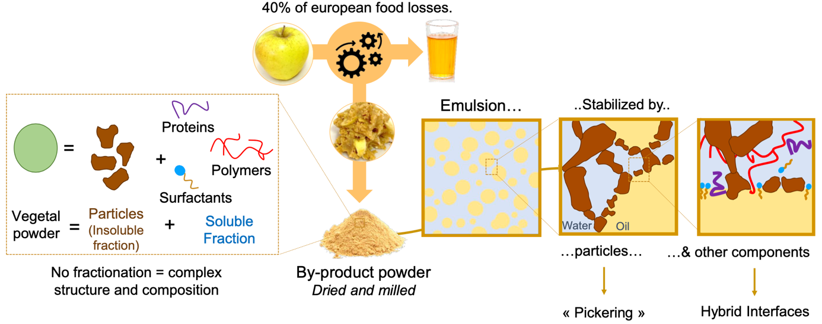

Figure 1: Valorization of uncracked vegetal by-products (example of apple pomace) as emulsion stabilizer

