Development of a bio-based coating with barrier properties

Gabriela Azevedo¹, João Ribeiro², Ana Isabel Bourbon¹, Olga Castro²,Lorenzo Pastrana ¹ and Miguel Cerqueira ¹

¹ INL - International Iberian Nanotechnology Laboratory, Av. Mestre José Veiga s/n 4715-330, Braga, Portugal
²Vizelpas—Flexible Films, S.A., Rua da Fundição, 8, Vilarinho, 4795-791 Santo Tirso, Portugal

Currently, one of the big challenges of the food packing industry is to reduce the multilayers films and to substitute some synthetic polymers with biopolymers that could improve the recyclability of packaging and thus increase their sustainability. This work aimed to develop a bio-based coating to decrease the barrier properties (water and oxygen permeability) of a monolayer polyethylene (PE) film. The materials selected for producing the coatings were cellulose nanocrystal (CNC) and zein, which were applied on the surface of polyethylene film using different deposition levels. Moreover, a bilayer system using CNC and zein was studied. In order to improve the adhesion of the coating to the surface was applied a plasma treatment. Barrier (water vapour transmission rate (WVTR) and oxygen transmission rate (OTR)), mechanical (tensile strength, Young’s Modulus and elongation at break) and optical properties were studied. Moreover, the dispersion of coatings by scanning electronic microscopy (SEM) was evaluated. Results showed that the developed coatings decreased the PE film barrier properties. The oxygen and water permeability decreased around 90-95 % and 35-40 %, respectively, when compared with PE film without coating (control).The optical properties of PE films were affected by the developed coatings, mainly with zein coating. The SEM analyses showed that the CNC coating was better distributed than the zein coating on polyethylene’s surface.

Acknowledgements:

This research was developed within the scope of Project No. 46.091, “BETTER PLASTICS – PLASTICS IN A CIRCULAR ECONOMY”, co-financed by the Competitiveness and Internationalization Operational Program (PO CI) and by the Lisbon Regional Operational Program (PO LISBOA), through Portugal 2020 and the European Regional Development Fund—FEDER.

Financed by:

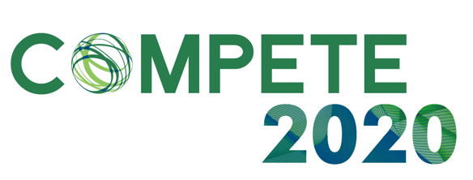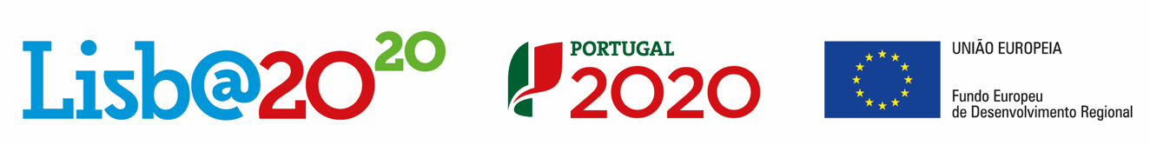

Conference theme: Hydrocolloid functional materials
Abstract submission for: Poster presentation

