High internal phase canola oil-in-water Pickering emulsions stabilised by cellulose nanocrystals (CNC)

L Sridharan¹, SH Hosseini-Parvar^{2*} and M Lad²

¹Food Process Engineering, Wageningen University and Research, 6708 WG Wageningen, the Netherlands
²Fonterra Research and Development Centre, Private Bag 11029, Dairy Farm Road, Palmerston North, 4442, New Zealand

Pickering emulsions are attractive as they are stabilised by natural materials that reduce the use of synthetic emulsifiers in food¹. Cellulose being one of the most abundant class of ingredients naturally available makes it a good choice for production of Pickering emulsions². In recent years, there has been a trend toward using more natural emulsifiers for food applications so cellulose nanocrystals (CNC) stabilised Pickering emulsions have been explored for food product based applications. But, there are limited studies on food grade high internal oil-water emulsions. Therefore, in this study, emulsions of up to 60wt% canola oil in water were prepared using CNC with a conventional emulsification process and characterised using different methods. The resultant CNC Pickering emulsions had small droplet diameter (D43: 3.6-7.4 µm) and were stable against coalescence at ambient temperature. The emulsions had a stable interface as viewed through Confocal microscopy. The addition of salt was found to be necessary to emulsify oil which is a characteristic of CNC prepared by sulphuric acid hydrolysis. Rheological behaviour of the emulsion showed weak gel structure with the gel strength increasing for higher oil fraction emulsions and the emulsions also had a shear thinning behaviour resembling that of aqueous CNC dispersions. A change in pH (between pH4 and pH9) showed no impact on the emulsion stability. This could be an indication that there is no protein impurity in the stabiliser, hence there is no pH induced effect. Energy dispersive x-ray spectroscopy (EDXS) showed no traces of protein impurity in CNC used in this study. Cryo-SEM imaging of the emulsions showed the rod particles of CNC covered the interface more dense than spherical particles³.
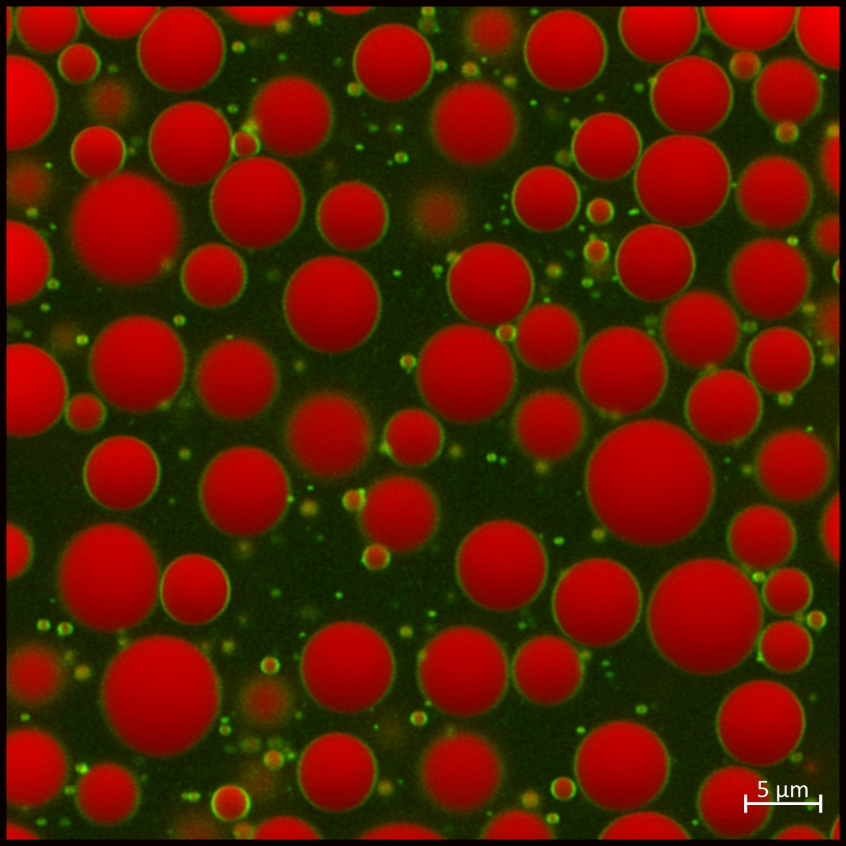
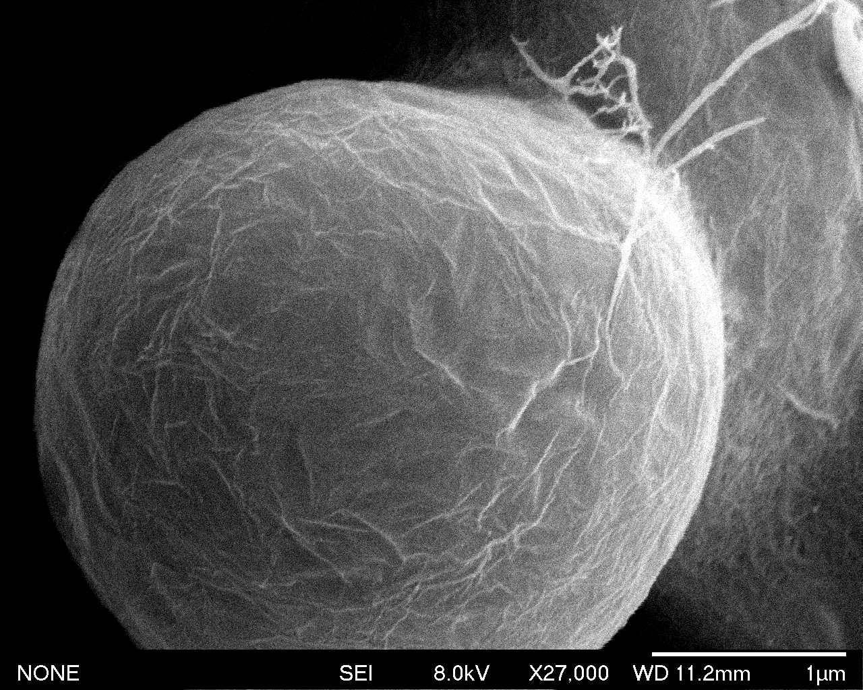
O/W emulsions stabilised by CNC
ɸ= 0.6

References:
1 Bon, S. A. F. (2015). The Phenomenon of Pickering Stabilization: A Basic Introduction, in Particle-Stabilized Emulsions and Colloids: Formation and Applications, T. Ngai and S.A.F. Bon, Ed., The Royal Society of Chemistry, Cambridge, pp. 1-7.
2 Rojas, J., Bedoya, M. and Ciro, Y. (2015). Current trends in the production of cellulose nanoparticles and nanocomposites for biomedical applications, in Cellulose: Fundamenal Aspects and Current trends, M. Poletto, Ed., InTech Open, pp. 193-228.
3 Donev A., Stillinger F.H., Chaikin P.M., and Torquato S. (2004). Unusually dense crystal packings of ellipsoids. Physical Review Letters, 92:255506.

