Alginate-chitosan microgels at interfaces. Structural, interfacial and emulsion stability aspects.

EP Kalogianni and A. Charisis

Department of Food Science and Technology, International Hellenic University, P.O. Box 141, 57400, Sindos, Thessaloniki, Greece

Microgels are “smart” colloidal entities that simultaneously exhibit polymer-like and particle-like characteristics. Interfacially active microgels can be used to stabilize emulsions. Depending on their nature, microgels may deform after adsorption on the interface and partially interconnect. This is expected to improve the viscoelastic rheological behaviour of the interface and therefore to affects emulsion stability. This work presents the structural and interfacial properties of chitosan-coated alginate microgels via Confocal Laser Microscopy, H¹ relaxometry, dynamic interfacial tension measurements at the oil/water interface and dynamic interfacial dilatational rheological measurements and relates the interfacial and structural properties of the microgels to their performance to form and stabilize emulsions. The formed emulsions properties and stability are characterized via laser diffraction and microscopy. The results show that the degree of cross linking affects the size of microgel particles whereas the addition of chitosan improves interfacial adsorption. The interfacial rheological behaviour of the microgels at the oil-water interface is affected by the pH as well as by the degree of crosslinking and this is in turn related to the emulsion stability. H¹ relaxometry shows significant differences between microgels of different compositions suggesting the ability of these systems to act as tailored interfacial structures for the controlled release of bioactive compounds for the protection of oxidation labile lipids and human health.

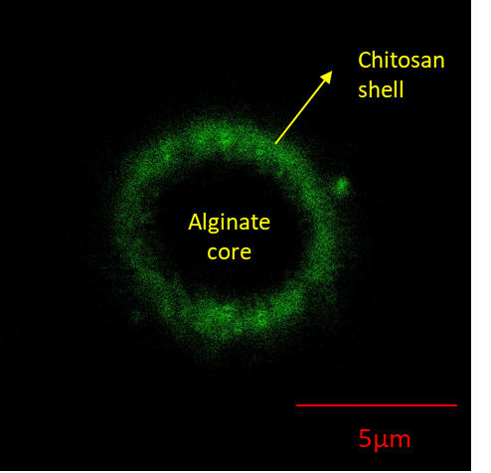_{(a)} 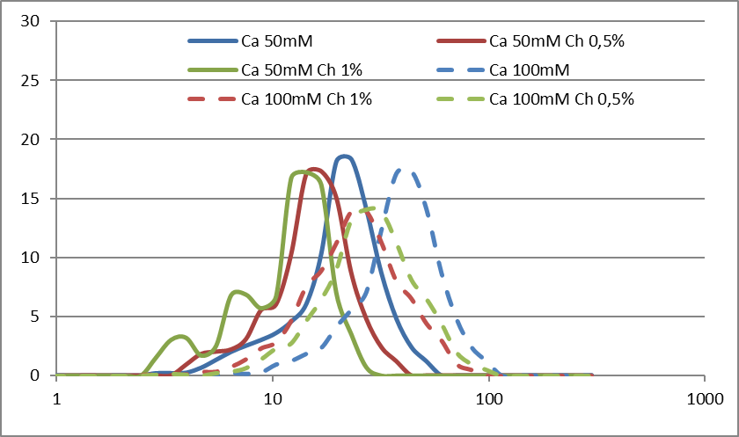 _{(b)}

(a) Alginate-chitosan microgel particle showing the chitosan shell and alginate core and (b) effect of composition on the droplet size distribution of oil-in-water emulsions stabilized by alginate-chitosan microgels

Acknowledgements: This research has been co-financed by the European Union and Greek national funds through the Operational Program Competitiveness, Entrepreneurship and Innovation, under the call RESEARCH— CREATE—INNOVATE (project code: Τ2ΕΔΚ-02279 -title “Human nutrition, animal and fish feeding on microalgae derived products through sustainable photosynthetic autotrophic cultures”).

